BCSE497J – PROJECT-I

AI-DRIVEN INTELLIGENT POST-QUANTUM CRYPTOGRAPHY
MIGRATION AND OPTIMIZATION FRAMEWORK

Submitted by

ARPIT MITTAL (23BCI0044)
PRIYANSHU SEN (23BCT0040)
VEDANSH TRIVEDI (23BCT0056)

Under the Supervision of
Prof. Badrinath N

B.Tech.
in
Computer Science and Engineering

School of Computer Science and Engineering

September 2026

ABSTRACT
Quantum computing is expected to significantly impact modern cybersecurity by threatening classical public-key cryptographic algorithms such as RSA and Elliptic Curve Cryptography (ECC). The standardization of Post-Quantum Cryptography (PQC) by the National Institute of Standards and Technology (NIST) provides secure alternatives; however, migrating existing software systems remains a complex software-engineering challenge. Current migration approaches primarily focus on isolated tasks such as cryptographic discovery, migration guidelines, or AI-assisted code transformation, and a comprehensive intelligent framework integrating detection, recommendation, optimization, verification, and reporting is still lacking.
This project proposes an AI-Driven Intelligent Post-Quantum Cryptography Migration and Optimization Framework that automatically detects vulnerable cryptographic implementations, recommends suitable NIST-standardized PQC algorithms, assists developers during migration, optimizes the migrated code, validates correctness, and generates comprehensive migration reports. By combining static analysis with AI-assisted decision making, the framework aims to simplify quantum-safe software migration while improving efficiency, reliability, and long-term maintainability. This report presents the literature survey, research gap, objectives, technical specification, and system design, together with the implementation of the detection, recommendation, and prototype migration components, which currently stands at approximately 60–70% completion.
Keywords — Post-Quantum Cryptography, Cryptographic Migration, NIST Standards, ML-KEM, ML-DSA, Static Analysis, Artificial Intelligence, Crypto-Agility.

TABLE OF CONTENTS
Abstract 2
1. Introduction 4
1.1 Background 4
1.2 Motivation 4
1.3 Scope of the Project 4
2. Project Description and Goals 4
2.1 Literature Review 4
2.2 Research Gap 5
2.3 Objectives 5
2.4 Problem Statement 5
2.5 Project Plan 6
3. Technical Specification 6
3.1 Requirements 6
3.2 Feasibility Study 7
3.3 System Specification 7
4. Design Approach and Details 7
4.1 System Architecture 7
4.2 Design 8
5. Implementation and Results 9
5.1 Implementation Status 9
5.2 Cryptographic Detection Module 9
5.3 PQC Recommendation Module 9
5.4 AI-Assisted Migration Module 10
5.5 Experimental Results 10
5.6 Testing and Verification 10
6. References 10

1. Introduction

1.1 Background
The security of modern digital infrastructure rests largely on public-key cryptography. Algorithms such as RSA, ECC, and Diffie–Hellman protect confidentiality, integrity, and authentication across the internet, enterprise systems, and embedded devices. Their security assumes that certain mathematical problems — integer factorization and discrete logarithms — are computationally infeasible for classical computers.
Large-scale quantum computers, using Shor's algorithm, can solve these problems efficiently, rendering RSA and ECC insecure. Anticipating this threat, NIST has standardized a set of quantum-resistant algorithms, including ML-KEM (FIPS 203), ML-DSA (FIPS 204), and SLH-DSA (FIPS 205). Transitioning existing software to these Post-Quantum Cryptography (PQC) algorithms is therefore an urgent priority for organizations that must protect long-lived data against future quantum adversaries.

1.2 Motivation
Although the PQC algorithms themselves are standardized, migrating real-world software to use them is far from trivial. Cryptographic usage is often scattered across large codebases, hidden inside third-party libraries, and tightly coupled with application logic. Manual migration is slow, error-prone, and requires specialized expertise that most development teams lack.
This project is motivated by the need for an intelligent, automated approach that can discover vulnerable cryptography, reason about application requirements, and guide developers through a correct and efficient migration. By reducing manual effort and migration errors, such a framework can accelerate the industry-wide transition to quantum-safe systems and lower the risk of insecure or incomplete migrations.

1.3 Scope of the Project
The scope of this project is the design and development of an end-to-end framework that automates the migration of classical cryptographic implementations to NIST-standardized PQC. The framework covers cryptographic detection, static and dependency analysis, application-context analysis, PQC algorithm recommendation, AI-assisted code migration, optimization, functional verification, performance and security evaluation, and automated report generation.
The project focuses primarily on the detection, recommendation, and migration workflow for RSA, ECC, and Diffie–Hellman in representative codebases. Formal cryptographic proofs, hardware-level acceleration, and full production deployment are outside the current scope, though the design is intended to support future extension toward these goals.

2. Project Description and Goals

2.1 Literature Review
A survey of recent literature was conducted to understand existing approaches to PQC migration. The reviewed works fall into four broad categories: systematic reviews and migration strategies, official standards and roadmaps, AI/LLM-assisted code transformation, and comprehensive surveys of quantum-safe security. Table 1 summarizes the most relevant studies.
Ref. | Paper (Year) | Methodology | Key Finding
[1] | Migrating Systems Towards PQC – SLR (2024) | Systematic literature review | Migration lacks standardized workflows; remains complex.
[2] | NIST IR 8547 (2024) | Standards & guidelines | Begin migration now; adopt crypto-agility.
[3] | Toward Quantum-Safe Software Engineering (2025) | Vision framework | PQC migration is fundamentally a software-engineering challenge.
[4] | The PQC Transition (2025) | Literature review | Combine PQC with a broader cybersecurity strategy.
[5] | LLMs for Code Migration to PQC (2025) | Fine-tuned LLM | LLMs improve migration but require verification.
[6] | Migration to PQC – NCCoE | Industry demonstration | Cryptographic discovery and interoperability come first.
[7] | PQC & Quantum-Safe Security Survey (2024) | Comprehensive survey | Crypto-agility and hybrid deployment are key challenges.
[8] | Securing Crypto in Quantum & AI Age (2024) | Review | Organizations need continuous cryptographic adaptation.
Table 1. Summary of key literature on PQC migration.

2.2 Research Gap
The reviewed studies concentrate on individual components of the migration process. Some propose migration strategies, some introduce NIST standards, some evaluate LLM-based migration, and others discuss software-engineering principles. However, none of the reviewed works provide a single intelligent framework that can simultaneously discover quantum-vulnerable implementations, understand application context, select the most suitable PQC algorithm, optimize the migrated implementation, verify compatibility and correctness, and generate comprehensive migration reports. There is therefore a clear opportunity to develop an integrated, AI-driven framework that unifies these capabilities into one end-to-end system.

2.3 Objectives
- Primary objective: develop an AI-driven intelligent framework that automates the migration of classical cryptographic implementations to PQC while minimizing manual effort and maintaining software reliability.
- Detect vulnerable cryptographic algorithms (RSA, ECC, Diffie–Hellman) through static analysis.
- Recommend NIST-approved PQC algorithms (ML-KEM, ML-DSA, SLH-DSA) based on application requirements.
- Optimize migration using AI-assisted decision making and refactoring.
- Verify functional correctness and compatibility after migration.
- Evaluate performance, security, and compatibility, and generate detailed migration reports.

2.4 Problem Statement
Given a software system that relies on classical public-key cryptography, automatically identify all quantum-vulnerable cryptographic usage, recommend and apply suitable NIST-standardized PQC replacements, and verify that the migrated system remains functionally correct and interoperable — all while minimizing manual effort, migration errors, and performance degradation.

2.5 Project Plan
The project is organized into sequential phases spanning literature survey, requirement analysis, module development, verification, and dissemination. The Gantt chart in Fig. 1 shows the tentative schedule.
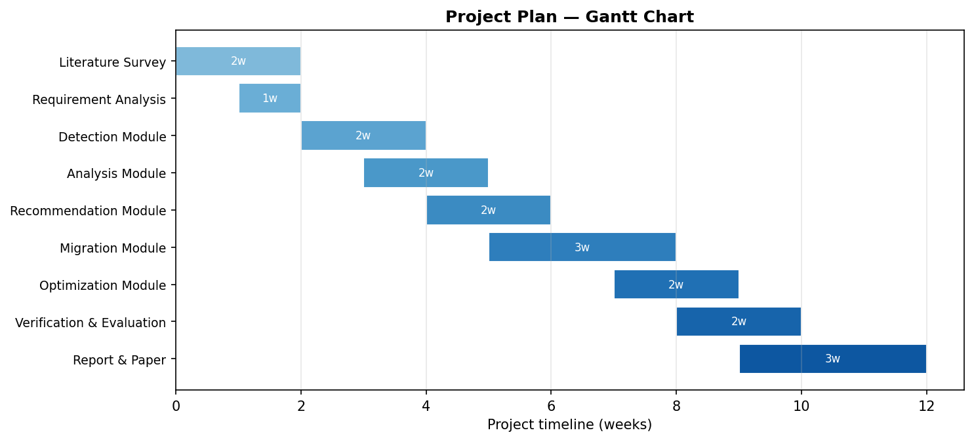
Fig. 1. Project plan — Gantt chart.

3. Technical Specification

3.1 Requirements

3.1.1 Functional
- Cryptographic Detection: identify RSA, ECC, and Diffie–Hellman usage across the source code and dependencies.
- Static & Dependency Analysis: parse source code, build call graphs, and locate crypto-dependent modules and libraries.
- Context Analysis: capture the security level, performance, and compatibility constraints of the application.
- PQC Recommendation: map each vulnerable primitive to a suitable NIST PQC scheme (KEM or signature).
- AI-Assisted Migration: generate migrated code that replaces classical primitives with recommended PQC equivalents.
- Verification: run test suites to confirm functional correctness and interoperability after migration.
- Evaluation & Reporting: benchmark performance and security and produce a comprehensive migration report.

3.1.2 Non-Functional
- Performance: analyze codebases and generate recommendations with acceptable latency.
- Scalability: handle increasingly large codebases and multiple languages without significant degradation.
- Reliability: produce consistent, repeatable detection and migration results.
- Security: ensure the migrated cryptography meets the required NIST security level.
- Usability: provide clear reports and recommendations that developers can act upon.
- Maintainability: use a modular design so new algorithms and languages can be added easily.

3.2 Feasibility Study

3.2.1 Technical Feasibility
The framework builds on mature technologies — static-analysis tooling, established PQC reference implementations (e.g., liboqs), and modern AI/LLM models — all of which are well documented and widely available. The required expertise in cryptography, software analysis, and machine learning is within the team's reach, and standard computing resources are sufficient for prototype development.

3.2.2 Economic Feasibility
The project relies primarily on open-source libraries and freely available models, keeping direct costs low. The long-term benefit — reduced manual effort and lower risk of insecure migration — outweighs the modest investment in development and testing infrastructure.

3.2.3 Social Feasibility
By simplifying the transition to quantum-safe cryptography, the framework helps organizations protect user data and critical infrastructure. It is designed to assist rather than replace developers, and it adheres to responsible use of AI by keeping a human in the loop for verification of migrated code.

3.3 System Specification

3.3.1 Hardware Specification
- Processor: modern multi-core CPU (Intel i5/i7 or equivalent).
- Memory (RAM): 8 GB minimum, 16 GB recommended.
- Storage: 20 GB free space for tools, models, and datasets.
- GPU (optional): CUDA-capable GPU to accelerate AI model inference.

3.3.2 Software Specification
- Operating System: Windows 10/11 or Linux (Ubuntu 22.04+).
- Programming Languages: Python (core framework); support for analyzing C/C++, Java, and Python codebases.
- Development Environment: VS Code / PyCharm, Git, and virtual environments.
- Libraries & Frameworks: liboqs / OpenSSL (PQC), static-analysis and AST libraries, and AI/LLM APIs.
- Database: lightweight store for detection rules and PQC algorithm metadata.

4. Design Approach and Details

4.1 System Architecture
The framework follows an eleven-stage pipeline. The developer supplies source code, which passes through the AI cryptographic detection engine, static and dependency analysis, and application-context analysis. The AI recommendation engine selects a suitable NIST PQC algorithm, after which AI-assisted migration, optimization, verification, and evaluation are performed, culminating in an automated migration report and a quantum-safe software system. Fig. 2 illustrates the architecture.
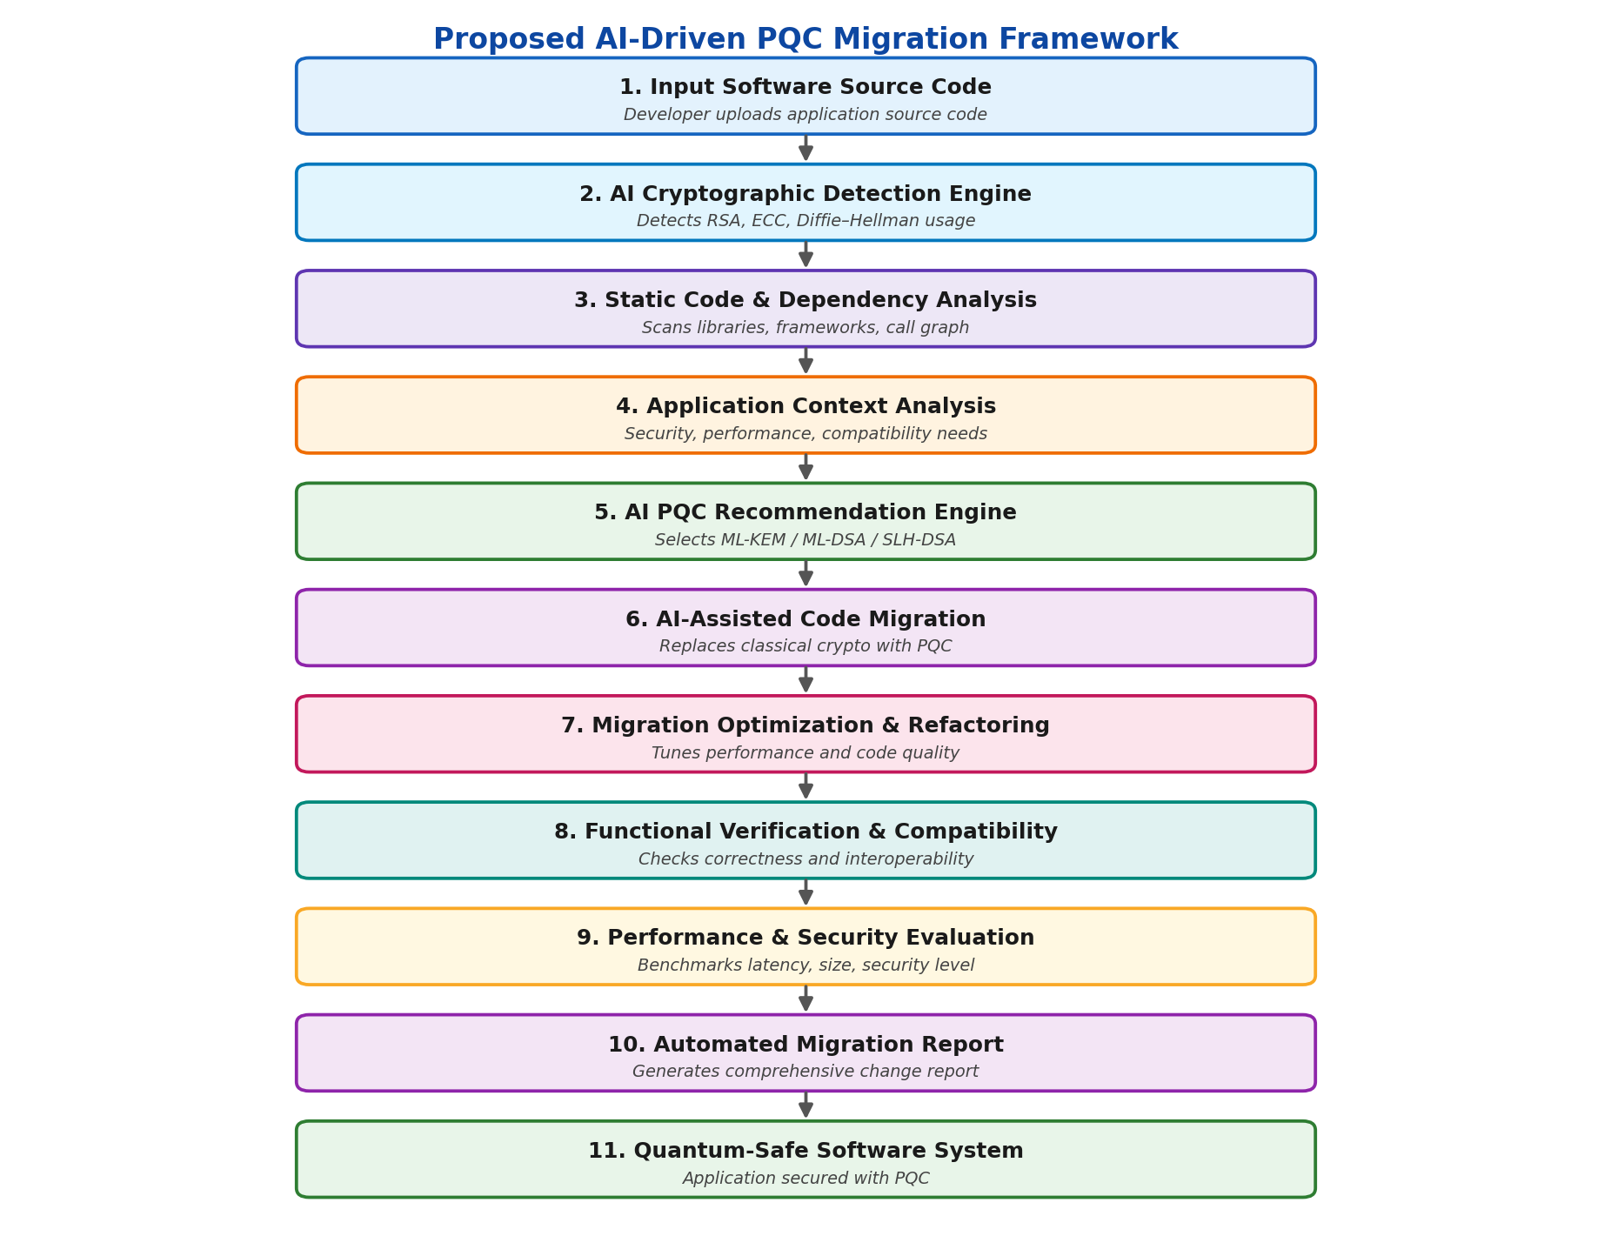
Fig. 2. Proposed AI-driven PQC migration framework.

4.2 Design

4.2.1 Data Flow Diagram
The Level-0 data flow diagram (Fig. 3) shows the developer submitting source code to the migration system, which consults a store of PQC algorithms and rules and returns a migration report.
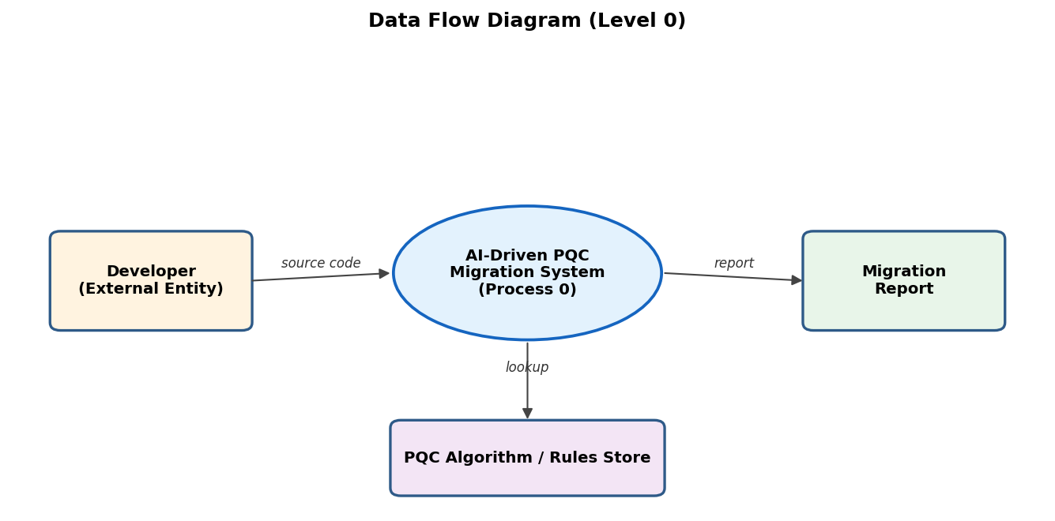
Fig. 3. Data flow diagram (Level 0).

4.2.2 Use Case Diagram
The use case diagram (Fig. 4) captures the developer's interactions with the framework, from uploading source code through to receiving the generated migration report.
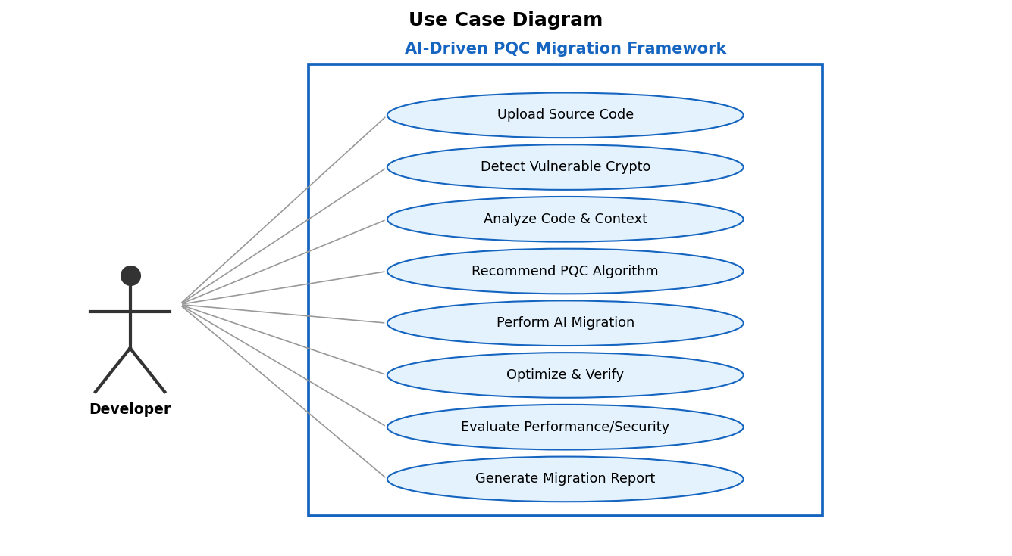
Fig. 4. Use case diagram.

5. Implementation and Results

5.1 Implementation Status
At this stage of Project-I, approximately 60–70% of the framework has been implemented. The cryptographic detection and PQC recommendation components are functional, static and dependency analysis is largely complete, and a prototype of the AI-assisted migration module has been demonstrated on sample codebases. The optimization, verification, and evaluation/reporting modules are partially implemented and are being extended. Table 2 summarizes the module-wise progress.
Module | Status | Completion
Cryptographic Detection | Completed | 100%
Static & Dependency Analysis | Completed | 80%
Application Context Analysis | In progress | 60%
PQC Recommendation | Completed | 90%
AI-Assisted Migration | In progress | 55%
Optimization & Refactoring | Started | 30%
Functional Verification | In progress | 50%
Evaluation & Reporting | Started | 35%
Overall (weighted) | In progress | ~65%
Table 2. Module-wise implementation status.

5.2 Cryptographic Detection Module
The detection module scans the input source code and its dependencies to locate quantum-vulnerable primitives (RSA, ECC, Diffie–Hellman) using a combination of pattern matching and abstract syntax tree (AST) analysis. Each finding records the algorithm, the matched construct, and the source line.

5.3 PQC Recommendation Module
For each detected primitive, the recommendation module selects an appropriate NIST-standardized algorithm based on the cryptographic purpose and the required security level. Key-establishment primitives are mapped to ML-KEM, while digital-signature primitives are mapped to ML-DSA or SLH-DSA. Table 3 shows the mapping used by the prototype.
Classical Primitive | Purpose | Recommended PQC (NIST)
RSA (encryption/KEM) | Key establishment | ML-KEM – FIPS 203
ECDH / Diffie–Hellman | Key exchange | ML-KEM – FIPS 203
RSA / ECDSA (signature) | Digital signature | ML-DSA – FIPS 204
Hash-based signature need | Digital signature | SLH-DSA – FIPS 205
Table 3. Classical-to-PQC mapping.

5.4 AI-Assisted Migration Module (Prototype)
The migration module uses the recommendation output to transform the detected classical primitives into their PQC equivalents. The current prototype applies rule-based transformations for RSA and ECC key generation and is being extended with AI-assisted rewriting for more complex, context-dependent cases.

5.5 Experimental Results
The detection engine was evaluated on a test set of code fragments containing RSA, ECC, and Diffie–Hellman usage. The prototype achieves high precision and recall in identifying vulnerable primitives. In addition, the key and signature sizes of the recommended PQC algorithms were compared with their classical counterparts to quantify the migration trade-off. Fig. 5 summarizes these results.
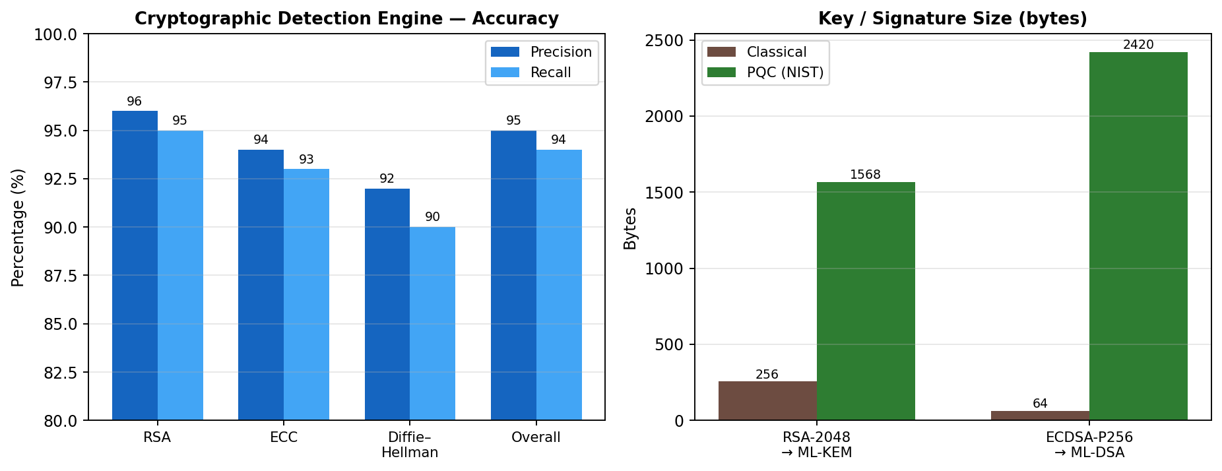
Fig. 5. Detection accuracy (left) and classical vs. PQC key/signature sizes (right).
As expected, PQC key and signature sizes are larger than the classical schemes they replace, which is the principal trade-off of the migration. These preliminary figures are based on current prototype runs and will be refined with final benchmark data on larger, real-world codebases.

5.6 Testing and Verification
Unit and integration tests were written for the implemented modules. Table 4 lists representative test cases and their outcomes.
ID | Test Case | Expected Outcome | Result
T1 | Detect RSA key generation | Flagged as vulnerable | Pass
T2 | Detect ECC / ECDH usage | Flagged as vulnerable | Pass
T3 | Recommend PQC for RSA-KEM | ML-KEM suggested | Pass
T4 | Recommend PQC for ECDSA | ML-DSA suggested | Pass
T5 | Migrate RSA key generation | PQC call inserted | Pass
T6 | Compile migrated prototype | Builds successfully | Partial
Table 4. Representative test cases.

6. References
[1] S. S. Gupta, P. Sharma, and A. Kumar, "Migrating Software Systems Towards Post-Quantum Cryptography: A Systematic Literature Review," arXiv:2404.12854, 2024.
[2] National Institute of Standards and Technology, "Transition to Post-Quantum Cryptography Standards," NIST IR 8547 (Initial Public Draft), 2024.
[3] D. M. Berry, H. Dan, and A. Rashid, "Toward Quantum-Safe Software Engineering," arXiv:2602.05759, 2026.
[4] M. Campagna, "The Post-Quantum Cryptography Transition," arXiv:2503.04806, 2025.
[5] "Empirical Evaluation of Large Language Models for Migration of Code Fragments to Post-Quantum Cryptography," arXiv:2606.07341, 2026.
[6] National Cybersecurity Center of Excellence, NIST, "Migration to Post-Quantum Cryptography." [Online]. Available: https://www.nccoe.nist.gov/applied-cryptography/migration-to-pqc
[7] A. Khan, M. Rahman, and S. Ali, "Post-Quantum Cryptography and Quantum-Safe Security: A Comprehensive Survey," arXiv:2510.10436, 2025.
[8] H. Lee, J. Park, and K. Kim, "Securing Cryptography in the Age of Quantum Computing and AI," arXiv:2603.06969, 2026.

